Agile methodology Notes

1. What is Agile?

Agile is a software development approach that focuses on:
- Iterative development (small increments)
- Continuous feedback
- Collaboration with stakeholders
- Flexibility to change
Instead of building the entire product at once, Agile delivers working software in small chunks (iterations/sprints).

2. Agile Principles & Values in Modern Software Development
Agile Values (Core Idea)
Agile prioritizes:
- Individuals and interactions over processes and tools
- Working software over comprehensive documentation
- Customer collaboration over contract negotiation
- Responding to change over following a fixed plan
Important: Right-side items matter, but left-side items matter more.

12 Agile Principles (Simplified)

- Customer satisfaction through early & continuous delivery
- Welcome changing requirements (even late in development)
- Deliver working software frequently
- Business & developers collaborate daily
- Build projects around motivated individuals
- Face-to-face communication is best
- Working software = primary progress measure
- Maintain sustainable development pace
- Focus on technical excellence & good design
- Simplicity is essential
- Self-organizing teams produce best results
- Regular reflection and improvement (retrospectives)

In Modern Development
Agile is widely used in:
- Startups (fast iteration)
- Product companies (continuous releases)
- DevOps environments (CI/CD pipelines)

3. Agile Manifesto in Real-World Projects
Example 1: E-commerce Website
- Instead of building everything first:
  - Sprint 1: Login system
  - Sprint 2: Product listing
  - Sprint 3: Payment
✔ Customers can give feedback early

Example 2: Mobile App
- Users request feature changes
- Agile allows quick updates instead of waiting months

4. Scrum Framework
Scrum is the most popular Agile framework.

Scrum Roles
1. Product Owner
- Represents customer
- Defines requirements (Product Backlog)
- Prioritizes features
2. Scrum Master
- Facilitates Scrum process
- Removes obstacles
- Ensures team follows Agile principles
3. Development Team
- Developers, testers, designers
- Self-organizing team
- Delivers working product

Scrum Events
1. Sprint
- Time-boxed iteration (usually 2–4 weeks)
- Goal: deliver working product increment

2. Sprint Planning
- Decide:
  - What to build?
  - How to build?

3. Daily Standup (Daily Scrum)
- 15-minute meeting
- Each member answers:
  - What did I do yesterday?
  - What will I do today?
  - Any blockers?

4. Sprint Review
- Demo of completed work
- Feedback from stakeholders

5. Sprint Retrospective
- Team reflects:
  - What went well?
  - What to improve?

Scrum Artifacts

1. Product Backlog
- List of all features (user stories)

2. Sprint Backlog
- Tasks selected for current sprint

3. Increment
- Final working product after sprint

5. Agile Estimation & Planning
Story Points
- Measure complexity, not time
- Factors:
  - Effort
  - Risk
  - Difficulty
Common scale: Fibonacci
1, 2, 3, 5, 8, 13

Planning Poker
A team-based estimation technique:
Steps:
- Each member gets cards (story points)
- A user story is discussed
- Everyone picks a number secretly
- Cards revealed simultaneously
- Discuss differences and agree
✔ Prevents bias
✔ Encourages team discussion

6. Agile User Stories
Format
As a [user], I want [feature], so that [benefit]
Example:
As a customer, I want to add items to cart, so that I can purchase products.

Acceptance Criteria
Defines when a story is complete.
Example:
- User can add items to cart
- Cart updates correctly
- Total price is calculated
- Items persist after refresh
✔ Must be:
- Clear
- Testable
- Measurable

7. Agile Metrics & Reporting
Burndown Chart
Shows:
- Remaining work vs time
Helps track sprint progress
Interpretation:
- Downward line = good progress
- Flat line = delay

Velocity
- Amount of work completed in a sprint (story points)
Example:
- Sprint 1: 20 points
- Sprint 2: 25 points
Average velocity = 22.5
✔ Helps in future planning

8. SDLC vs Agile
Feature | Traditional SDLC (Waterfall) | Agile
Approach | Sequential | Iterative
Flexibility | Low | High
Customer Feedback | Late | Continuous
Delivery | End of project | Frequent releases
Requirement Changes | Difficult | Easy
Risk | High | Reduced
Testing | After development | Continuous

Key Difference
- SDLC (Waterfall): Plan everything first, then build
- Agile: Build, test, and improve continuously

9. Case Study: E-commerce Website Development
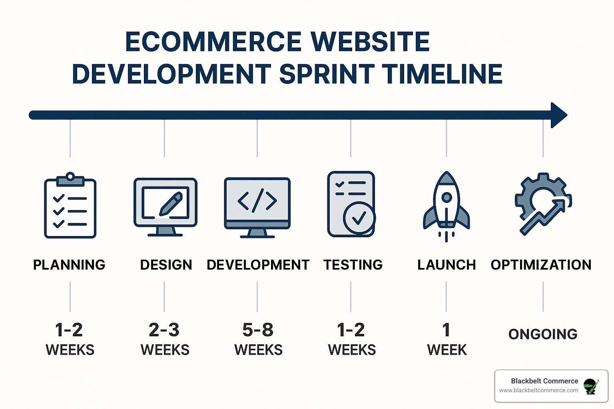

Problem
A company wants to build an online shopping platform but:
- Requirements keep changing
- Competitors launch new features quickly
- Customers expect fast delivery

Agile Approach
Sprint 1:
- User registration & login
- Basic homepage
Sprint 2:
- Product listing
- Search functionality
Sprint 3:
- Cart system
- Checkout

User Story Example
As a customer, I want to search products so that I can find items quickly.
Acceptance Criteria:
- Search bar visible
- Results appear within 2 seconds
- Supports keyword filtering

Outcome
✔ Early product launch (MVP)
✔ Continuous updates based on feedback
✔ Reduced risk of failure

10. Summary
Agile is about:
- Delivering value quickly
- Adapting to change
- Collaborating effectively
- Continuous improvement
Scrum helps implement Agile through:
- Defined roles
- Structured events
- Clear deliverables

Quick Revision Points
- Agile = iterative + flexible development
- Scrum = framework to implement Agile
- Story Points = effort estimation
- Planning Poker = team estimation
- Burndown = progress tracking
- Velocity = team performance
- User Stories = requirements in simple language

11. Important interview questions

- What is Agile methodology, and why is it used in software development?
- What are the key differences between Agile and traditional Waterfall models?
- What are the four values of the Agile Manifesto?
- Can you explain the 12 Agile principles?
- What is Scrum, and how does it fit into Agile?
- What are the roles in Scrum, and what are their responsibilities?
- What are the different Scrum events (ceremonies)?
- What are Scrum artifacts, and why are they important?
- What is a sprint, and how is it planned?
- What is a user story, and how do you write one?
- What are acceptance criteria in Agile?
- What are story points, and how are they different from hours?
- What is Planning Poker, and how does it work?
- What is velocity in Agile, and how is it calculated?
- What is a burndown chart, and how is it used?
- How do you handle changing requirements in Agile projects?
- What is the role of a Scrum Master in a team?
- What challenges have you faced while working in Agile, and how did you overcome them?
- How do Agile teams ensure quality throughout the development process?
- What is the difference between a Product Backlog and a Sprint Backlog?

All the best and Happy Learning

